Name: Kalyani Sachin Powar
Roll No: 49
LAB EXERCISE :1

1.Develop the HTML page named as “Myfirstwebpage.html”. Add the following tags with relevant content.
1. Set the title of the page as “My First Web
2. Within the body use the following tags:
a) Moving text = “Basic HTML Tags”
b) Different heading tags (h1 to h6)
c) Paragraph
d) Horizontal line
e) Line Break
f) Block Quote
g) Pre tag
h) Different Logical Style ( etc.)
Code: -
<!doctype html>
<html lang="en">
<head>
<meta charset="utf-8">
<meta name="viewport"content="width=device-width,initial-scale=1.0">
<title> My first web page</title>
</head>
<body>
<marquee>basic html tags</marquee>
<h1>Heading 1</h1>
<h2>Heading 2</h2>
<h3>Heading 3</h3>
<h4>Heading 4</h4>
<h5>Heading 5</h5>
<h6>Heading 6</h6>
<p> this is a paragraph.</p>
<hr>
<p>this is a paragraph with a<br>line break.</p>
<blockquote>
"this is a block quote.
</blockquote>
<pre>
this is a pre-formatted text
</pre>
<strong>this is a strong text.</strong>
<em>this is an emphasized text.</em>
</body>
</html>
OUTPUT:
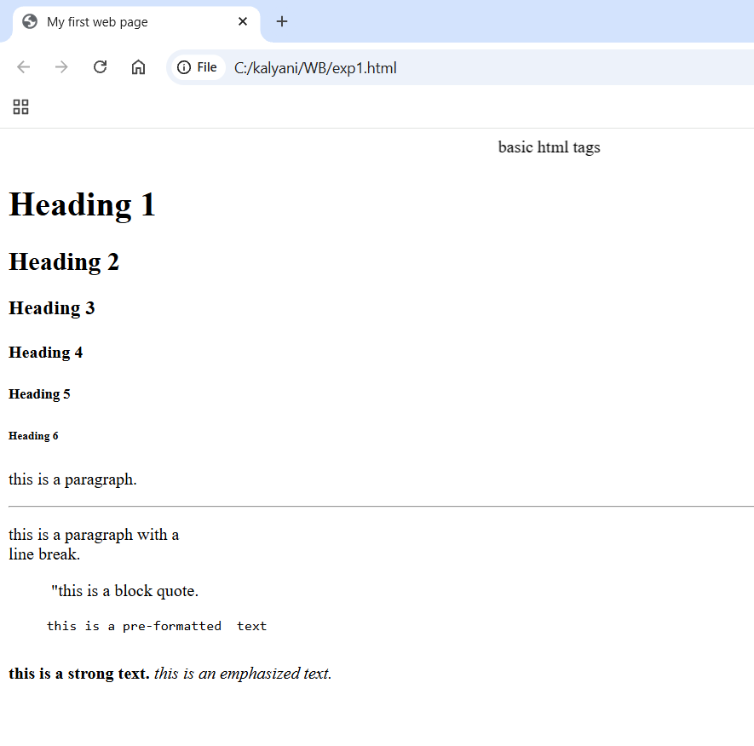

LAB EXERCISE:2

2. Develop the HTML page named as “Table.html” to display your class time table.
a) Provide the title as Time Table with table header and table footer, row-span and col-span etc.
b) Provide various colour options to the cells
c) Provide colour options for rows.
Code: -
<!Doctype html>
<html lang="en">
<head>
<meta charset="UTF-8">
<meta name="viewport" content="width=device-width, initial-scale=1.0">
<title> Time Table </title>
<style>
table{
width:100%;
border-collapse:collapse;
}
th,td{
border:1px solid black;
padding:10px;
text-align:center;
}
.highlight{
background-color: #ffcccb;
}
.elective{
background-color: #ccffcc;
}
</style>
</head>
<body>
<h1 style="text-align:center;"> MCA I SEM II Time Table </title>
<table>
<thead>
<tr>
<th>Monday</th>
<th>Tuesday</th>
<th>Wednesday</th>
<th>Thursday</th>
<th>Friday</th>
<th>Saturday</th>
<th>Sunday</th>
</tr>
</thead>
<tbody>
<tr>
<td>9:30AM to 10:30AM</td>
<td class="highlight">Data Structure</td>
<td class="elective">Big Data Management</td>
<td class="highlight">Web Technology</td>
<td class="elective">Big Data Management</td>
<td class="highlight">Web Technology</td>
<td class="elective">Big Data Management</td>
</tr>
<tr>
<td>10:30AM to 11:30AM</td>
<td class="highlight">Big Data Management</td>
<td class="elective">Data Structure</td>
<td class="highlight">Software Engineering</td>
<td class="elective">Web Technology</td>
<td class="highlight">Digital Marketing</td>
<td class="elective">Data Structure</td>
</tr>
<tr>
<td>11:30AM to 12:30PM</td>
<td class="highlight">Digital Marketing</td>
<td class="elective">Web Technology</td>
<td class="highlight">Data Communication & Network</td>
<td class="elective">Data Communication & Network</td>
<td class="highlight">Data Structure</td>
<td class="elective">Data Communication & Network</td>
</tr>
<tr>
<td>12:30PM to 1:30PM</td>
<td>B</td>
<td>R</td>
<td>E</td>
<td>A</td>
<td>K</td>
<td></td>
</tr>
<tr>
<td>1:30PM to 2:30PM</td>
<td class="highlight">Software Engineering</td>
<td class="elective">Digital Marketing</td>
<td class="highlight">Digital Marketing</td>
<td class="elective">Software Engineering</td>
<td class="highlight">Software Engineering</td>
<td class="elective">Data Communication & Network</td>
</tr>
<tr>
<td>2:30PM to 3:30PM</td>
<td class="highlight">Mini Project</td>
<td class="elective">Mini Project</td>
<td class="highlight">Lab Based on CC201</td>
<td class="elective">Lab Based on CC202</td>
<td class="highlight">Mini Project</td>
<td class="elective">Mini Project</td>
</tr>
<tr>
<td>3:30PM to 4:30PM</td>
<td class="highlight">Mini Project</td>
<td class="elective">Mini Project</td>
<td class="highlight">Lab Based on CC201</td>
<td class="elective">Lab Based on CC202</td>
<td class="highlight">Mini Project</td>
<td class="elective">Mini Project</td>
</tr>
</tbody>
</table>
</body>
</html>
OUTPUT:
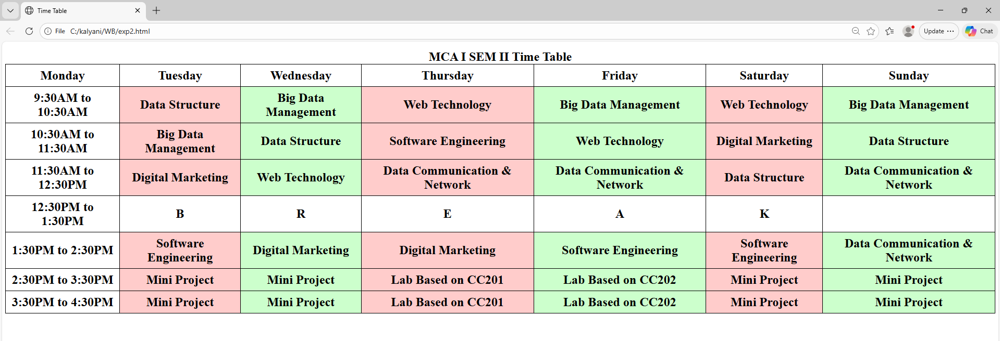

LAB EXERCISE:3

3. Develop an external style sheet named as “style.css” and provide different styles for h2, h3, hr, p, div, span, time, img & a tags. Apply different CSS selectors for tags and demonstrate the significance of each.
Code: -
<!Doctype Html>
<head>
<style>
h2 {
color: blue;
font-size: 24px;
}
h3 {
color: green;
}
hr {
border: 2px solid red;
}
p {
font-size: 18px;
}
div {
background-color: #f0f0f0;
padding: 10px;
}
</style>
</head>
<body>

<h2>This is an H2 Heading</h2>
<h3>This is an H3 Heading</h3>
<div>
<p>This paragraph is inside a div element with a background color and padding.</p>
</div>
<time datetime="2024-11-17">November 17, 2024</time>
<p>Here is an image example:</p>
<img src="butterfly.jpg" alt="butterfly Image">
</body>
</html>
OUTPUT:
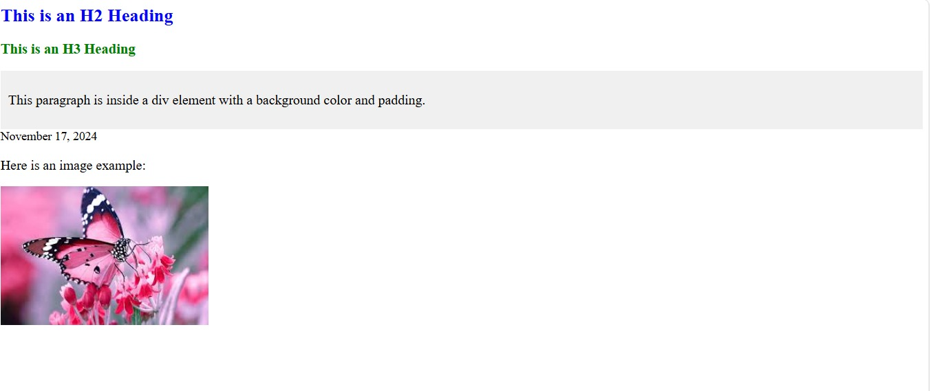

LAB EXERCISE:4

4. Develop HTML page named as “registration.html” having variety of HTML input elements with background colors, table for alignment & provide font colors & size using CSS styles.
Code:-
<!doctype html>
<html lang="en">
<head>
<meta charset="utf-8">
<meta name="viewport"content="width=device-width,initial-scale=1.0">
<title>Registration page</title>
<style>
body{
background-color:#e0f7a;
font-family:arial,sans-serif;
display:flex;
justify-content:center;
align-items:center;
height:100vh;
margin:0;
}
.form-container{
background-color:#ffffff;
padding:20px 30px;
border-radius:10px;
box-shadow:0 8px 16px rgba(0,0,0,0.2)
max-width:400px;
width:100%;
}
h2{
text-align:center;
color:#090909;
margin-bottom:20px;
}
table{
width:100%
}
td{
padding:10px;
}
label{
font-weigth:bold;
color:#555555;
}
input[type="text"],
input[type="email"],
input[type="password"]{
width:100%;
padding:10px;
border:1px solid #cccccc;
border-radius:5px;
}
.radio-group,
.checkbox-group{
display:flex;
gap:10px;
align-item:center;
}
input[type="radio"],
input[type="checkbox"]{
margin-right:5px;
}
button{
width:100%
padding:12px;
background-color:#5b4af5;
color:#ffffff;
border:none;
border-radius:5px;
font-size:16px;
cursor:pointer;
transition:background-color0.3s ease;
}
button:hover{
background-color:#004d40;
}
</style>
</head>
<body>
<div class="from-container">
<h2>Registration Form</h2>
<form action="#">
<table>
<tr>
<td><label for="name">Name:</label></td>
<td><input type="text"id="name"name="name"placeholder="enter your name"></td>
</td>
</tr>
<tr>
<td><label for="email">Email:</label></td>
<td><input type="email"name="email"placeholder="enter your
email” </td>
</tr>
<tr>
<td><label for="password">Password:</label></td>
<td><inputtype="password"id="password"name="password"placeholder="enter your password"></td>
</tr>
<tr
<td><label for="gender">Gender:</label></td>
<td class="radio-group">
<input type="radio" id="male"name="gender"value="male">
<label for="male">Male</label>
<input type="radio"id="female"name="gender"value="female">
<label for="female">Female</label>
</td>
</tr>
<tr>
<td><label for="accept">AcceptTerms:</label></td>
<td class="checkbox-group">
<input type="checkbox"id="accept"name="accept">
<label for="accept">I agree to the terms</label>
</td>
</tr>
<tr>
<td colspan="2">
<button type="submit">Register</button>
</td>
</tr>
</table>
</form>
</div>
</body>
</html>
OUTPUT:
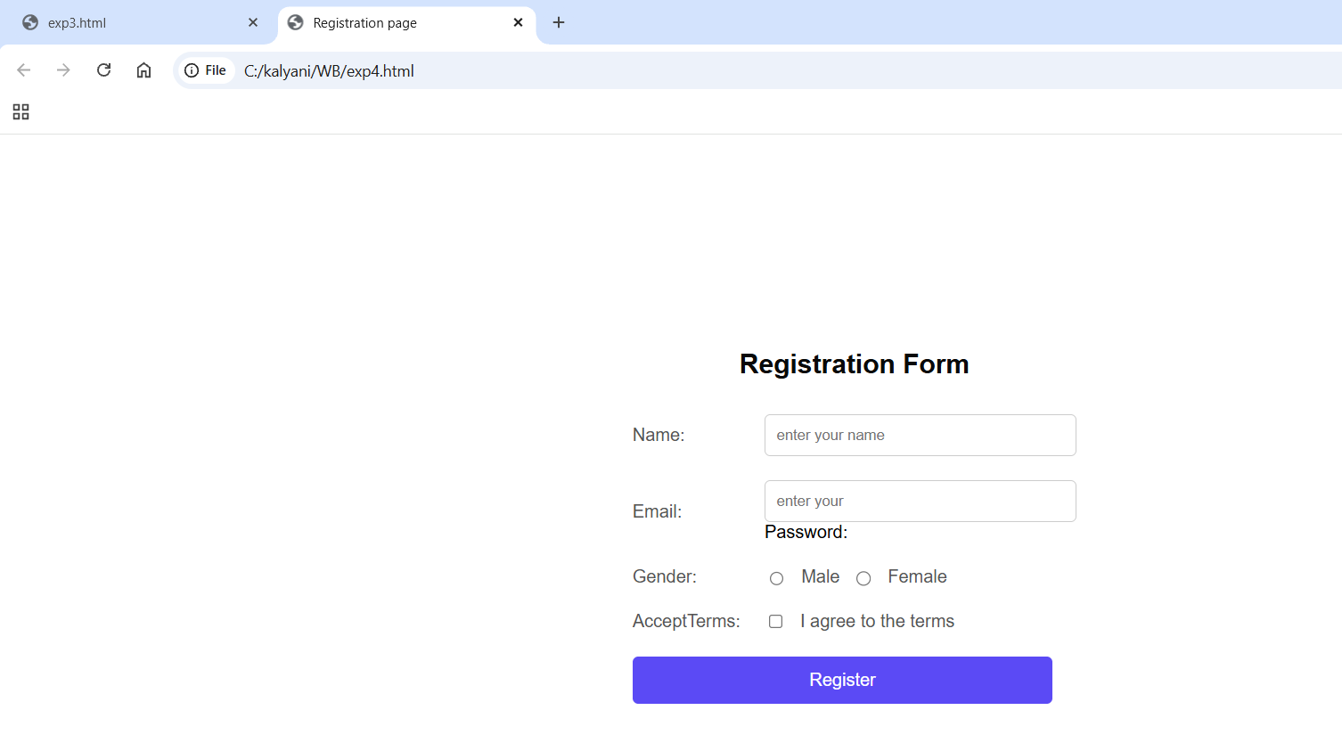

LAB EXERCISE:5

5. Develop HTML page named as “newpaper.html” having variety of HTML semantic elements with background colors, text-colors & size for figure, table, aside, section, article, header, footer… etc
Code:-
<!DOCTYPE html>
<html lang="en">
<head>
<meta charset="UTF-8">
<meta name="viewport" content="width=device-width, initial-scale=1.0">
<title>Modern Newspaper</title>
<style>
/* General Styling */
body {
font-family: 'Segoe UI', Tahoma, Geneva, Verdana, sans-serif;
background-color: #f5f5f5;
color: #333;
margin: 0;
padding: 0;
}
/* Header Styling */
header {
background-color: #c5139b;
color: #ffffff;
padding: 40px 20px;
text-align: center;
box-shadow: 0 4px 8px rgba(0, 0, 0, 0.2);
}
header h1 {
margin: 0
font-size: 2.5em;
}
/* Article Styling */
article {
background-color: #ffffff;
padding: 30px;
margin: 20px auto;
max-width: 800px;
border-radius: 10px;
box-shadow: 0 6px 12px rgba(0, 0, 0, 0.1);
}
article h2 {
color: #c62828;
font-size: 2em;
}
article p {
line-height: 1.6;
font-size: 1.1em;
}
/* Section Styling */
section {
background-color: #e0f7fa;
padding: 20px;
margin: 20px auto;
max-width: 800px;
border-radius: 10px;
box-shadow: 0 6px 12px rgba(0, 0, 0, 0.1);
}
section h3 {
color: #00796b;
font-size: 1.8em;
}
section p {
font-size: 1.1em;
line-height: 1.6;
}
/* Footer Styling */
footer {
background-color: black;
color: #ffffff;
padding: 20px;
text-align: center;
box-shadow: 0 -4px 8px rgba(0, 0, 0, 0.2);
}
footer p {
margin: 0;
font-size: 1em;
}
/* Responsive Design */
@media (max-width: 600px) {
header, article, section, footer {
padding: 15px;
}
header h1 {
font-size: 2em;
}
article h2, section h3 {
font-size: 1.5em;
}
article p, section p {
font-size: 1em;
}
}
</style>
</head>
<body>
<header>
<h1>Modern Newspaper</h1>
</header>
<article>
<h2>Breaking News</h2>
<p>Today’s top story: A significant breakthrough in technology has been made,
impacting industries worldwide. Stay tuned for more updates as we follow the story closely.
</p>
</article>
<section>
<h3>Sports Section</h3>
<p>The local team secured a dramatic victory in the final minutes of the game. Fans are
ecstatic as the team advances to the championship. Catch all the highlights and player
interviews in this section.</p>
</section>
<footer>
<p>© 2024 Modern Newspaper. All rights reserved. </p>
</footer>
</body>
</html>
OUTPUT:
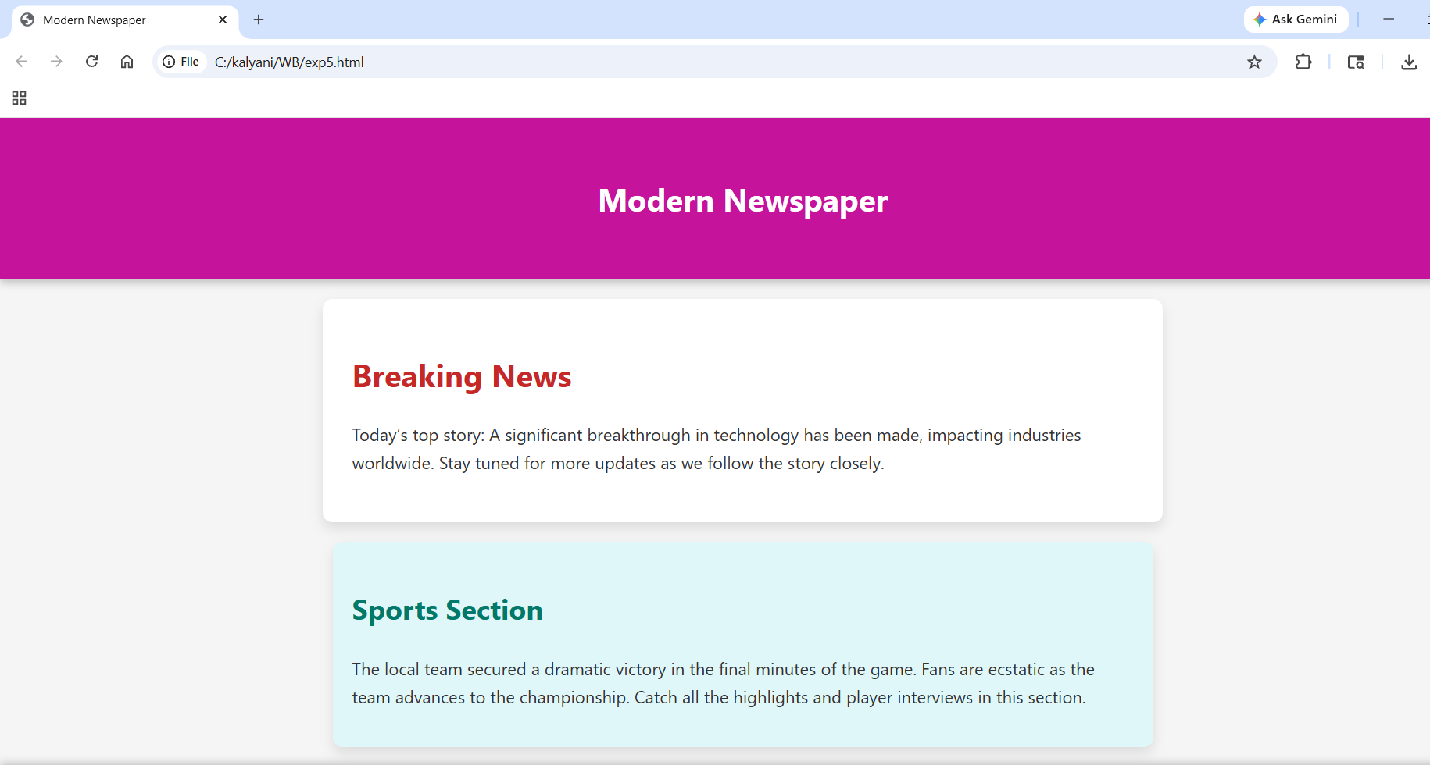

LAB EXERCISE:6

6. Apply HTML, CSS and JavaScript to design a simple calculator to perform the following operations: sum, product, difference, remainder, quotient, power, square-root and square.
Code:-
<!DOCTYPE html>
<html lang="en">
<head>
<meta charset="UTF-8">
<meta name="viewport" content="width=device-width, initial-scale=1.0">
<title>Simple Calculator</title>
<style>
/* Body Styling */
body {
font-family: 'Segoe UI', Tahoma, Geneva, Verdana, sans-serif;
background-color: #dfe1e3;
color: #ecf0f1;
display: flex;
justify-content: center;
align-items: center;
height: 100vh;
margin: 0;
}
/* Calculator Container */
.calculator {
background-color: #34495e;
padding: 20px;
border-radius: 15px;
box-shadow: 0 10px 20px rgba(0, 0, 0, 0.5);
width: 320px;
}
/* Display Styling */
#result {
width: 94%;
height: 60px;
font-size: 1.5em;
padding: 10px;
margin-bottom: 15px;
border: none;
border-radius: 10px;
background-color: #f763e1;
color: #2c3e50;
text-align: right;
}
/* Button Styling */
.buttons {
display: grid;
grid-template-columns: repeat(4, 1fr);
gap: 10px;
}
input[type="button"] {
width: 100%;
height: 60px;
font-size: 1.2em;
border: none;
border-radius: 10px;
background-color: #3498db;
color: #ecf0f1;
cursor: pointer;
transition: all 0.3s ease;
}
input[type="button"]:hover {
background-color: #2980b9;
}
input[type="button"]:active {
background-color: #1c6ea4;
}
/* Special Buttons */
.equal {
background-color: #e74c3c;
}
.equal:hover {
background-color: #c0392b;
}
.clear {
background-color: #f39c12;
}
.clear:hover {
background-color: #e67e22;
}
</style>
</head>
<body>
<div class="calculator">
<h1>Simple Calculator</h1>
<input type="text" id="result" disabled>
<div class="buttons">
<input type="button" value="1" onclick="append('1')">
<input type="button" value="2" onclick="append('2')">
<input type="button" value="3" onclick="append('3')">
<input type="button" value="+" onclick="append('+')">
<input type="button" value="4" onclick="append('4')">
<input type="button" value="5" onclick="append('5')">
<input type="button" value="6" onclick="append('6')">
<input type="button" value="-" onclick="append('-')">
<input type="button" value="7" onclick="append('7')">
<input type="button" value="8" onclick="append('8')">
<input type="button" value="9" onclick="append('9')">
<input type="button" value="*" onclick="append('*')">
<input type="button" value="0" onclick="append('0')">
<input type="button" value="C" class="clear" onclick="clearResult()">
<input type="button" value="=" class="equal" onclick="calculate()">
<input type="button" value="/" onclick="append('/')">
</div>
</div>
<script>
// Function to append value to the input field
function append(value) {
document.getElementById('result').value += value;
}
// Function to clear the input field
function clearResult() {
document.getElementById('result').value = '';
}
// Function to calculate the result
function calculate() {
try {
let result = eval(document.getElementById('result').value);
document.getElementById('result').value = result;
} catch (error) {
alert('Invalid Expression');
clearResult();
}
}
</script>
</body>
</html>
OUTPUT:
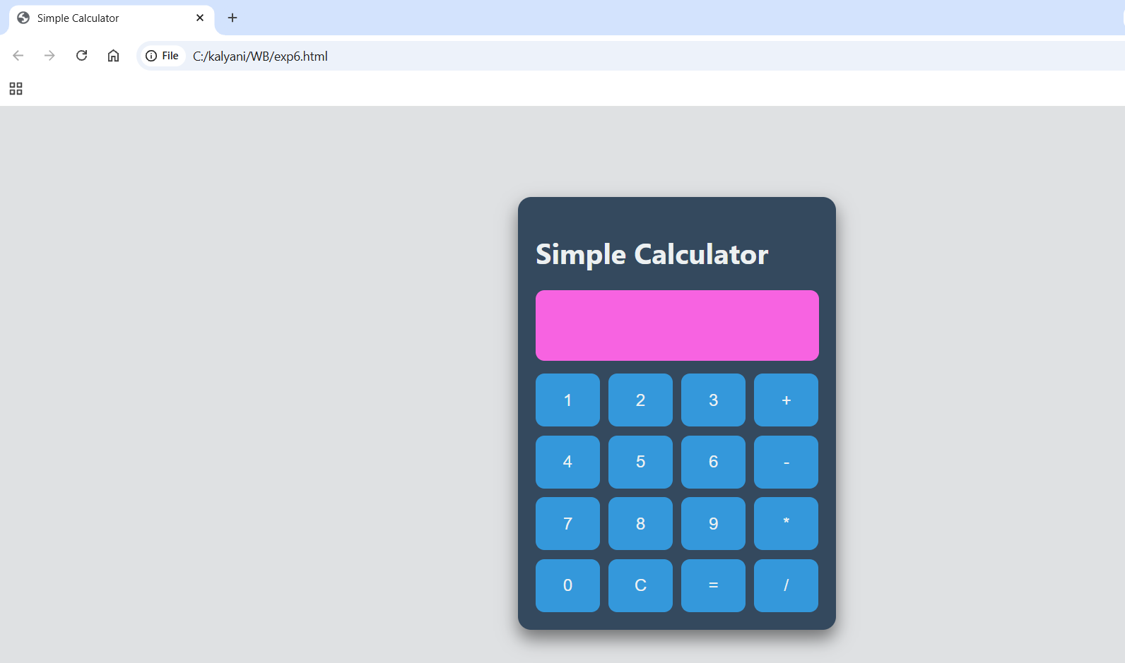

LAB EXERCISE:7

1)Write HTML program to demonstrate Heading tags
Code: -
<html>
<head>
<title>heading tag example</title>
</head>
<body>
<h1 align="center">heading tag</h1>
<hr color="green">
<h1 align="center">CIMDR</h1>
<h2 align="center">MCA</h2>
<h3 align="center">MBA</h3>
<h4 align="center">BCA</h4>
<h5 align="center">BBA</h5>
<h16 align="center">DBM</h6>
</body>
</html>
OUTPUT:
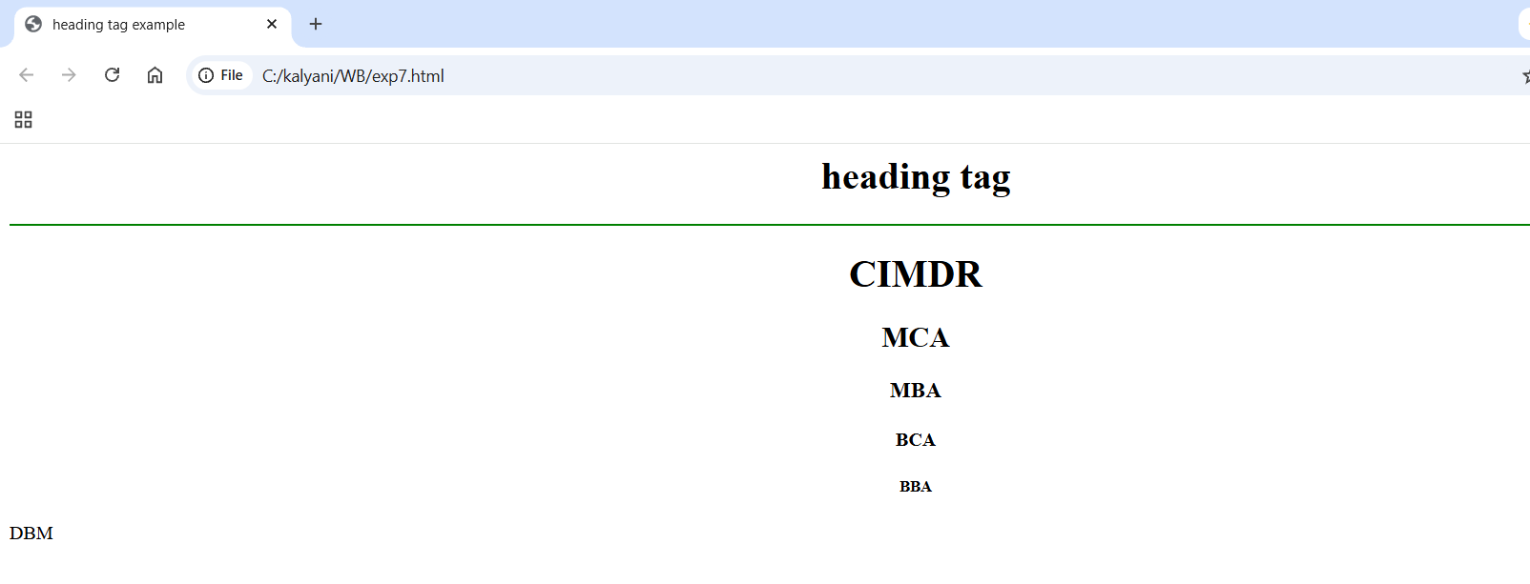
2)Write HTML Program to demonstrate Formatting tags
Code:-
<html>
<head>
<title>Text Formatting Tags</title>
</head>
<body>
<center>
<h1 align="center">Text Formatting Tags</h1>
<hr color="blue">
<p>This is <i> Italic Text</i></p>
<p>This is<u> Underlined text</u></p>
<p>This is<b> Bold Text</b></p>
<p>This is<em> Emphasized Text</em></p>
<p>This is<strong> Strong Text</strong></p>
<p>This is<s> Shrinked Text</s></p>
<p>This is<sup> Superscript Text</sup></p>
<p>This is<sub> Subscript Text</sub></p>
<p>This is<big> Big Text</big></p>
<p>This is<small> Small Text</small></p>
</center>
</body>
</html>
OUTPUT:
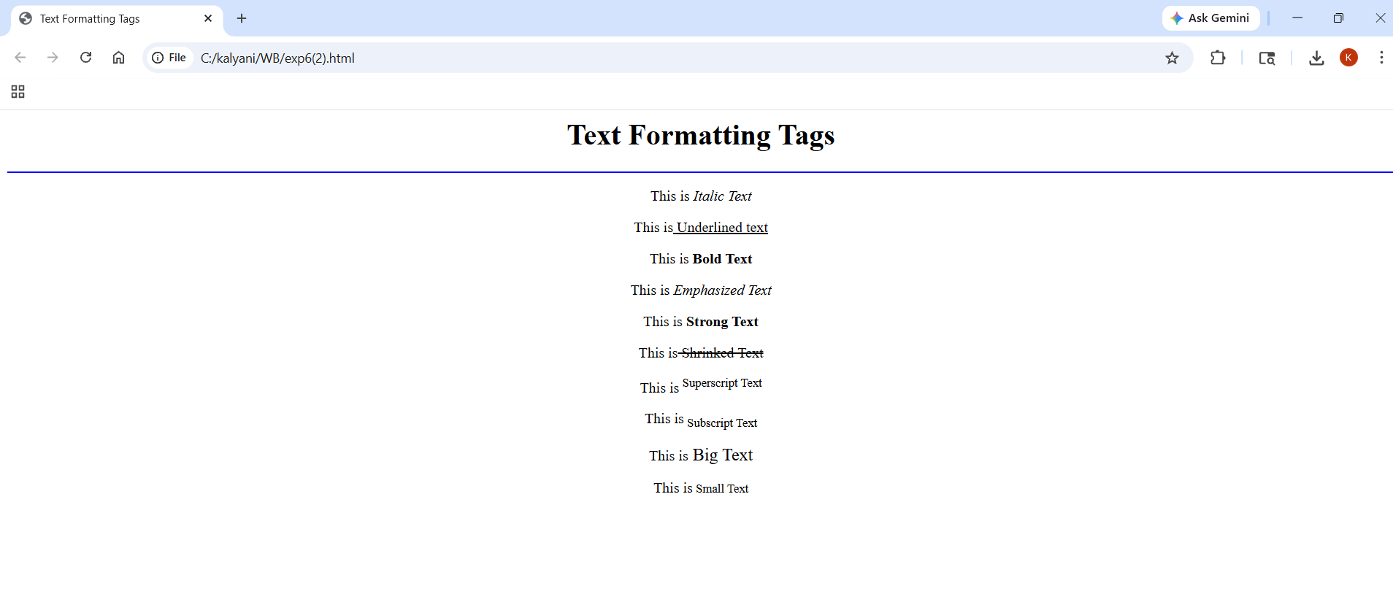

LAB EXERCISE:8

1) JavaScript function
Code:-
<html>
<head>
<script type="text/javascript">
function displaymessage()
{
alert("hello world")
}
</script>
</head>
<body>
<form>
<input type="button" value="click me" onclick="displaymessage()"/>
</form>
</body>
</html>
OUTPUT:
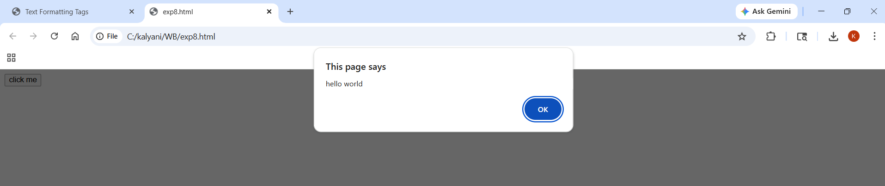
2)RETURN STATEMENT
Code:-
<html>
<body>
<script type="text/javascript">
var i=0;
while(i<=5)
{
document.write("the number is"+i);
document.write("<br />");
i++;
}
</script>
</body>
</html>
OUTPUT:-
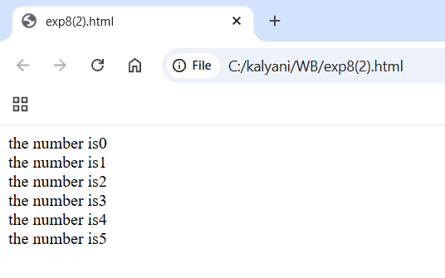

LAB EXERCISE:9

JAVASCRIPT LOOPS
1) For Loop
<html>
<body>
<script type="text/javascript">
var i=0;
for (i=0;i<=5;i++)
{
document.write("The number is " + i);
document.write("<br />");
}
</script>
</body>
</html>
OUTPUT:
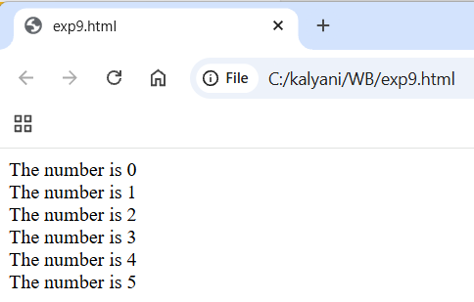
2) While Loop
<html>
<body>
<script type="text/javascript">
var i=0;
while (i<=5)
{
document.write("The
number is " + i);
document.write("<br />");
i++;
}
</script>
</body>
</html>
OUTPUT:
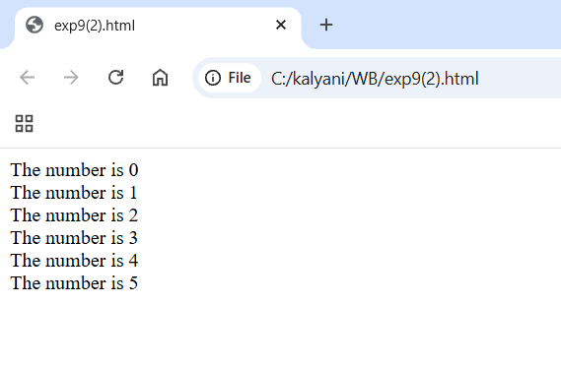
3) DO...WHILE LOOP
<html>
<body>
<script type="text/javascript">
var i=0;
do
{
document.write("The
number is " + i);
document.write("<br />");
i++;
}
while (i<=5);
</script>
</body>
</html>
OUTPUT:

4) THE BREAK STATEMENT
<html>
<body> <script type="text/javascript">
var i=0;
for (i=0;i<=10;i++)
{
if (i==3) break;
document.write("The number is " + i); document.write("<br />");
}
</script>
</body>
</html>
OUTPUT:
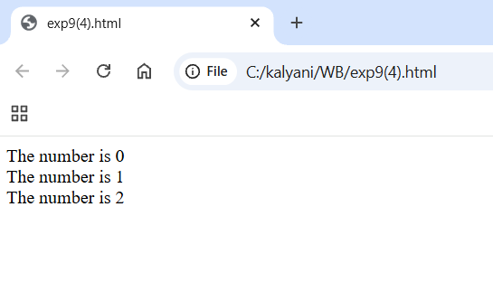
5) CONTINUE STATEMEN
<html>
<body>
<script type="text/javascript"> var i=0
for (i=0;i<=10;i++)
{
if (i==3)
{
continue;
}
document.write("The number is " + i); document.write("<br />");
}
</script>
</body>
</html>
OUTPUT:
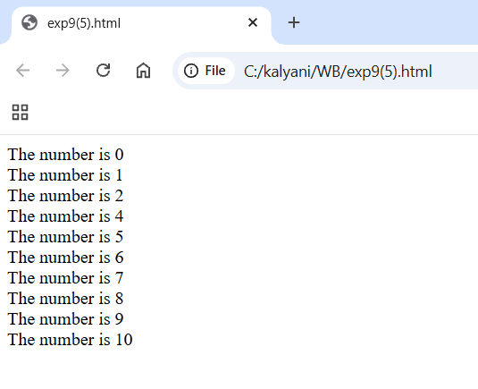
6) JAVASCRIPT FOR...IN STATEMENT
<html>
<body>
<script type="text/javascript"> var x;
var mycars = new Array(); mycars[0] = "Saab"; mycars[1] = "Volvo"; mycars[2] = "BMW";
for (x in mycars)
{
document.write(mycars[x] + "<br />");
}
</script>
</body>
</html>
OUTPUT:

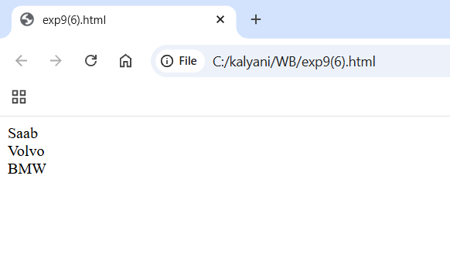
LAB EXERCISE:10

Demonstration on String Object
1. Return The Length of A String
<html>
<body>
<script type="text/javascript">
var txt = "Hello World!";
document.write(txt.length);
</script>
</body>
</html>
OUTPUT:
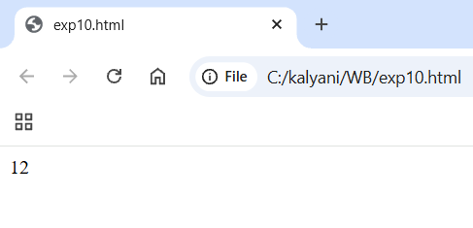
2. Style Strings
<html>
<body>
<script type="text/javascript">
var txt = "Hello World!";
document.write("<p>Big: " + txt.big() + "</p>");
document.write("<p>Small: " + txt.small() + "</p>");
document.write("<p>Bold: " + txt.bold() + "</p>");
document.write("<p>Italic: " + txt.italics() + "</p>");
document.write("<p>Fixed: " + txt.fixed() + "</p>");
document.write("<p>Strike: " + txt.strike() + "</p>");
document.write("<p>Fontcolor: " + txt.fontcolor("green") + "</p>");
document.write("<p>Fontsize: " + txt.fontsize(6) + "</p>");
document.write("<p>Subscript: " + txt.sub() + "</p>");
document.write("<p>Superscript: " + txt.sup() + "</p>");
document.write("<p>Link: " + txt.link("http://www.w3schools.com") + "</p>");
document.write("<p>Blink: " + txt.blink() + " (does not work in IE, Chrome, or
Safari)</p>");
</script>
</body>
</html>
OUTPUT:
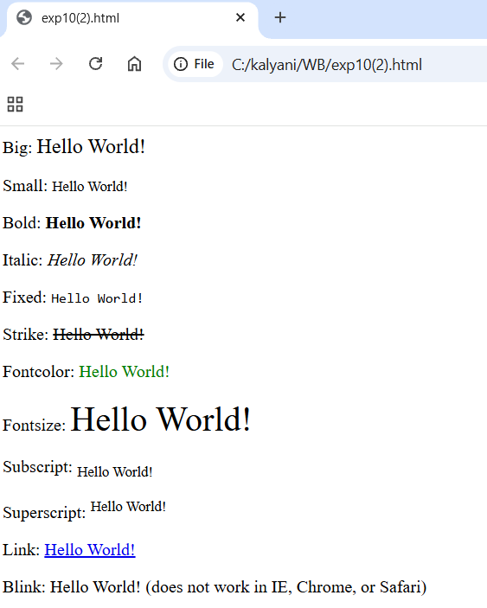
3. Return the Position of the First Occurrence of A Text in A String - indexof():
<html>
<body>
<script type="text/javascript">
var str="Hello world!";
document.write(str.indexOf("d") + "<br />");
document.write(str.indexOf("WORLD") + "<br />");
document.write(str.indexOf("world"));
</script>
</body>
</html>
OUTPUT:

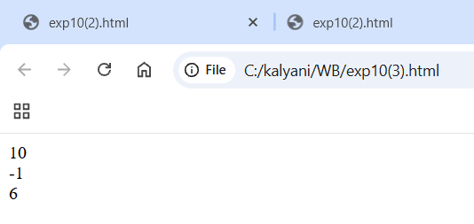
4. Search for A Text in A String and Return the Text If Found - Match():
<html>
<body>
<script type="text/javascript">
var str="Hello world!";
document.write(str.match("world") + "<br />");
document.write(str.match("World") + "<br />");
document.write(str.match("worlld") + "<br />");
document.write(str.match("world!"));
</script>
</body>
</html>
OUTPUT:

5. Replace Characters in A String - Replace() :
<html>
<body>
<script type="text/javascript">
var str="Visit Microsoft!";
document.write(str.replace("Microsoft","W3Schools"));
</script>
</body>
</html>
OUTPUT:

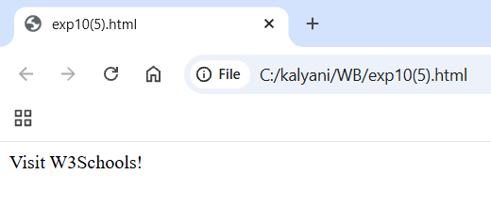
6. Convert a String to Lowercase Letters:
<html>
<body>
<script type="text/javascript">
var str="Hello World!";
document.write(str.toLowerCase());
</script>
</body>
</html>
OUTPUT:
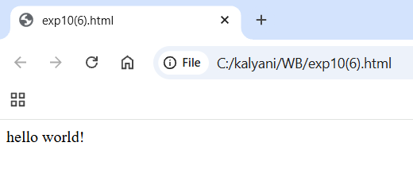

LAB EXERCISE:11

Demonstration on Date Object
1. Use Date() to Return Today's Date And Time
<html>
<body>
<script type="text/javascript">
var d=new Date();
document.write(d);
</script>
</body>
</html>
OUTPUT:
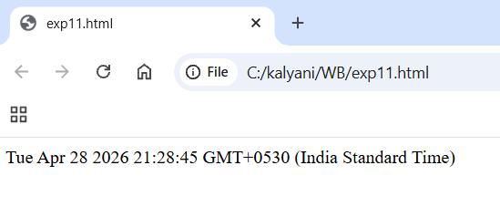
2. Use getTime() to Calculate the Years Since 1970
<html>
<body>
<script type="text/javascript">
var d=new Date();
document.write(d);
</script>
</body>
</html>
OUTPUT:
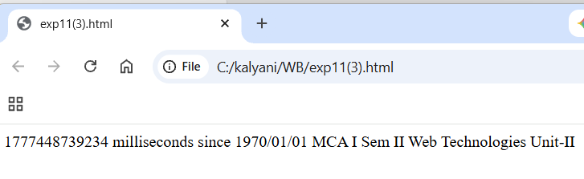
3. Use setFullYear() to Set a Specific Date
<html>
<body>
<script type="text/javascript">
var d = new Date();
d.setFullYear(1992,10,3);
document.write(d);
</script>
</body>
</html>
OUTPUT:
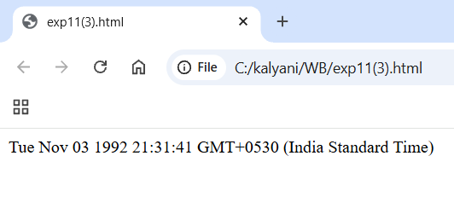
4. Use toUTCString() to Convert Today's Date (according to UTC) to A String
<html>
<body>
<script type="text/javascript">
var d=new Date();
document.write("Original form: ");
document.write(d + "<br />");
document.write("To string (universal time): ");
document.write(d.toUTCString());
</script>
</body>
</html>
OUTPUT:
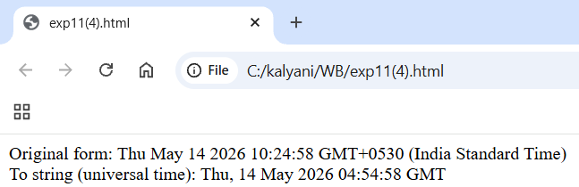
5. Use getDay() and An Array to Write a Weekday, and Not Just A Number
<html>
<body>
<script type="text/javascript">
var d=new Date();
var weekday=new Array(7);
weekday[0]="Sunday";
weekday[1]="Monday";
weekday[2]="Tuesday";
weekday[3]="Wednesday";
weekday[4]="Thursday";
weekday[5]="Friday";
weekday[6]="Saturday";
document.write("Today is " + weekday[d.getDay()]);
</script>
</body>
</html>
OUTPUT:
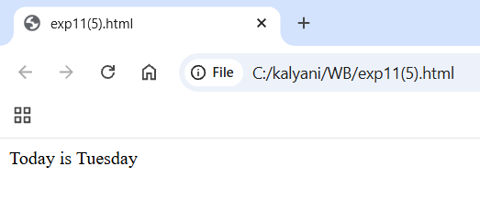
6. Display a Clock
<html>
<head>
<script type="text/javascript">
function startTime()
{
var today=new Date();
var h=today.getHours();
var m=today.getMinutes();
var s=today.getSeconds();
// add a zero in front of numbers<10
m=checkTime(m);
s=checkTime(s);
document.getElementById('txt').innerHTML=h+":"+m+":"+s;
t=setTimeout('startTime()',500);
}
function checkTime(i)
{
if (i<10)
{
i="0" + i;
}
return i;
}
</script>
</head>
<body onload="startTime()">
<div id="txt"></div>
</body>
</html>
OUTPUT:
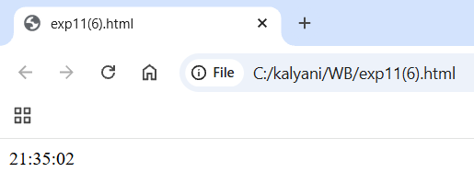

LAB EXERCISE:12

Demonstration on Array Object
1. Program for array concatenation
<html>
<body>
<script type="text/javascript">
var parents = ["Jani", "Tove"];
var children = ["Cecilie", "Lone"];
var family = parents.concat(children);
document.write(family);
</script>
</body>
</html>
OUTPUT:
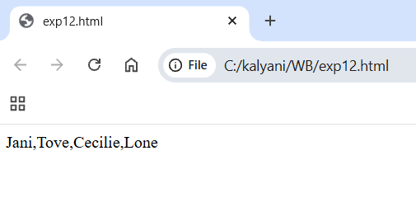
2. Program for array concatenation with multiple arrays.
<html>
<body>
<script type="text/javascript">
var parents = ["Jani", "Tove"];
var brothers = ["Stale", "KaiJim", "Borge"];
var children = ["Cecilie", "Lone"];
var family = parents.concat(brothers, children);
document.write(family);
</script>
</body>
</html>
OUTPUT:
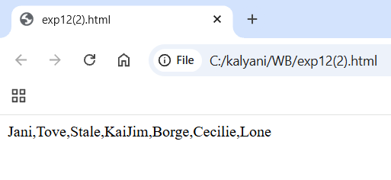
3. Program for array join operation
<html>
<body>
<script type="text/javascript">
var fruits = ["Banana", "Orange", "Apple", "Mango"];
document.write(fruits.join() + "<br />");
document.write(fruits.join("+") + "<br />");
document.write(fruits.join(" and "));
</script>
</body>
</html>
OUTPUT:
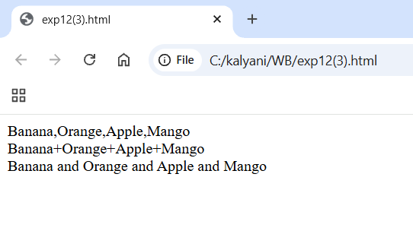
4. Program for array pop.
<html>
<body>
<script type="text/javascript">
var fruits = ["Banana", "Orange", "Apple", "Mango"];
document.write(fruits.pop() + "<br />");
document.write(fruits + "<br />");
document.write(fruits.pop() + "<br />");
document.write(fruits);
</script>
</body>
</html>
OUTPUT:
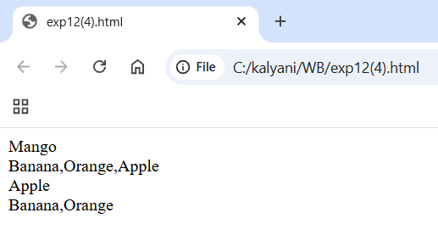
5.Program for array push.
<html>
<body>
<script type="text/javascript">
var fruits=["Banana","Orange","Apple","Mango"];
document.write(fruits.push("Kiwi") + "<br/>");
document.write(fruits.push("Lemon","Pineapple") + "<br/>");
document.write(fruits);
</script>
</body>
</html>
OUTPUT:
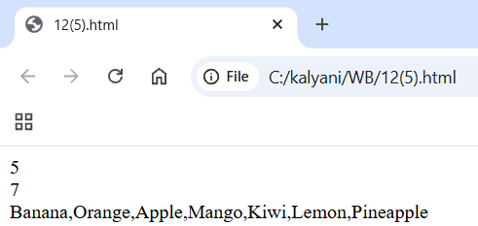

6. Program for array reverse.
<html>
<body>
<script type="text/javascript">
var fruits=["banana","orange","apple","mango"];
document.write(fruits.reverse());
</script>
</body>
</html>
OUTPUT:
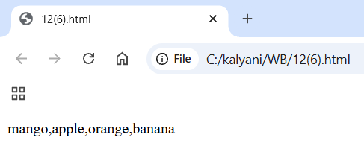
7.Program for array shift.
<html>
<body>
<script type="text/javascript">
var fruits=["Banana","Orange","Apple","Mango"];
document.write(fruits.shift() + "<br/>");
document.write(fruits + "<br/>");
document.write(fruits.shift + "<br/>");
document.write(fruits);
</script>
</body>
</html>
OUTPUT:
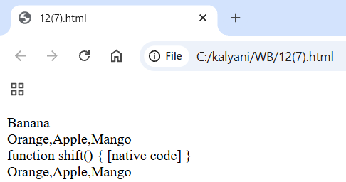
8.Program for array slice
<html>
<body>
<script type="text/javascript">
var friuts=["Banana","Orange","Apple","Mango"];
document.write(fruits.slice(0,1) + "<br/>");
document.write(fruits.slice(1) + "<br/>");
document.write(fruits.slice(-2) + "<br/>");
document.write(fruits);
</script>
</body>
</html>
OUTPUT:
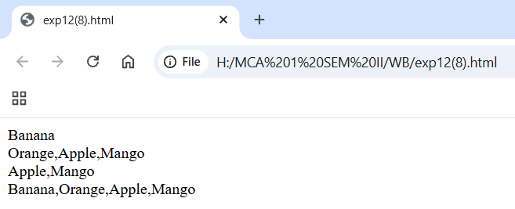
9.Program for array sort().
<html>
<body>
<script type="text/javascript">
var fruits=["Banana","Orange","Apple","Mango"];
document.write(fruits.sort());
</script>
</body>
</html>
OUTPUT:
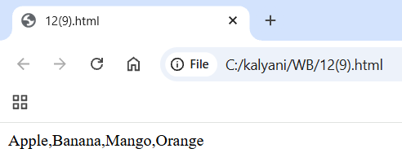
10.Program for array to string().
<html>
<body>
<script type="text/javascript">
var fruits=["Banana","Orange","Apple","Mango"];
document.write(fruits.toString());
</script>
</body>
</html>
OUTPUT:
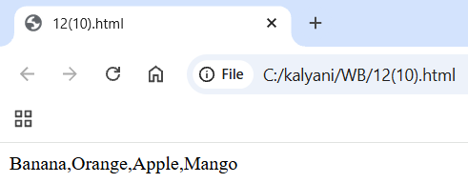

Lab experiment 13
1.Display an alert box:
<html>
<head>
<script type="text/javascript">
function show_alert()
{
alert("Hello! I am am alert box!");
}
</script>
</head>
</body>
<input type="button" onclick="show_alert()" value="show alert box"/>
</body>
</html>
OUTPUT:
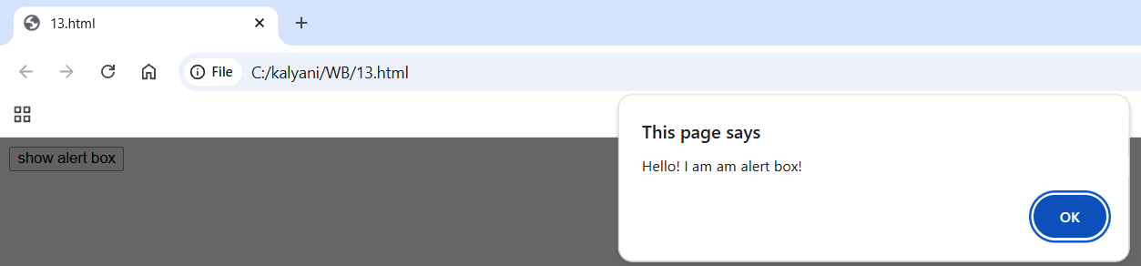
2. Display a prompt box:
<html>
<head>
<script type="text/javascript">
function show_prompt()
{
var name=prompt("please enter your name","Harry Potter");
if(name!=null&&name!="")
{
document.write("Hello"+name+"!How are you today?");
}
}
</script>
</head>
<body>
<input type="button" onclick="show_prompt()" value="show prompt box"/>
</body>
</html>
OUTPUT:
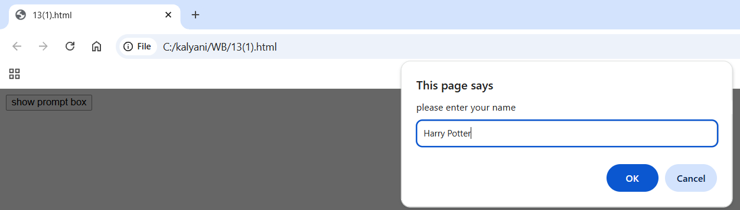
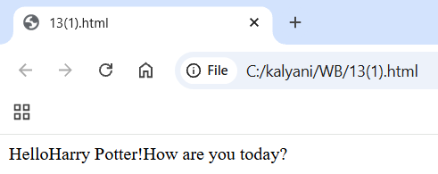
3.Display a confirm box, and alert what the visitor clicked
<html>
<head>
<script type="text/javascript">
function show_confirm()
{
var r=confirm("press a button!");
if (r==true)
{
alert("you pressed OK!");
}
else
{
alert("you pressed cancel!");
}
}
</script>
</head>
<body<html>
>
<input type="button" onclick="show_confirm()" value="show a confirm box"/>
</body>
</html>
OUTPUT:
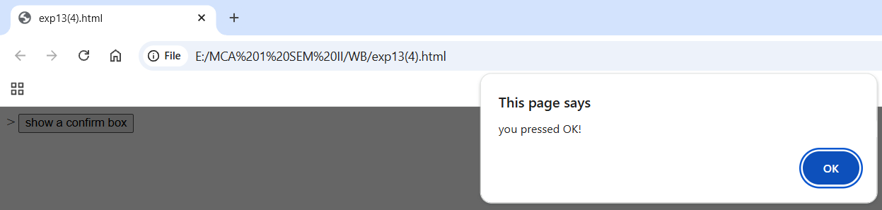
4. Create a pop-up window Open a new window when clicking on a button:
<html>
<head>
<script type="text/javascript"> function open_win()
{
window.open("http://kishor.ucoz.com");
}
</script>
</head>
<body>
<form>
<input type=button value="Open Window" onclick="open_win()">
</form>
</body>
</html>
OUTPUT:
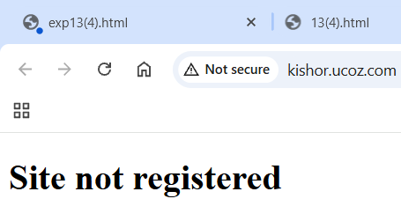

5. Open a new window and control its appearance:
<html>
<head>
<script type="text/javascript"> function open_win()
{
window.open("http://www.w3schools.com","_blank","toolbar=yes, location=yes, directories=no, status=no, menubar=yes, scrollbars=yes, resizable=no, copyhistory=yes, width=400, height=400");
}
</script>
</head>
<body>
<form>
<input type="button" value="Open Window" onclick="open_win()">
</form>
</body>
</html>
OUTPUT:
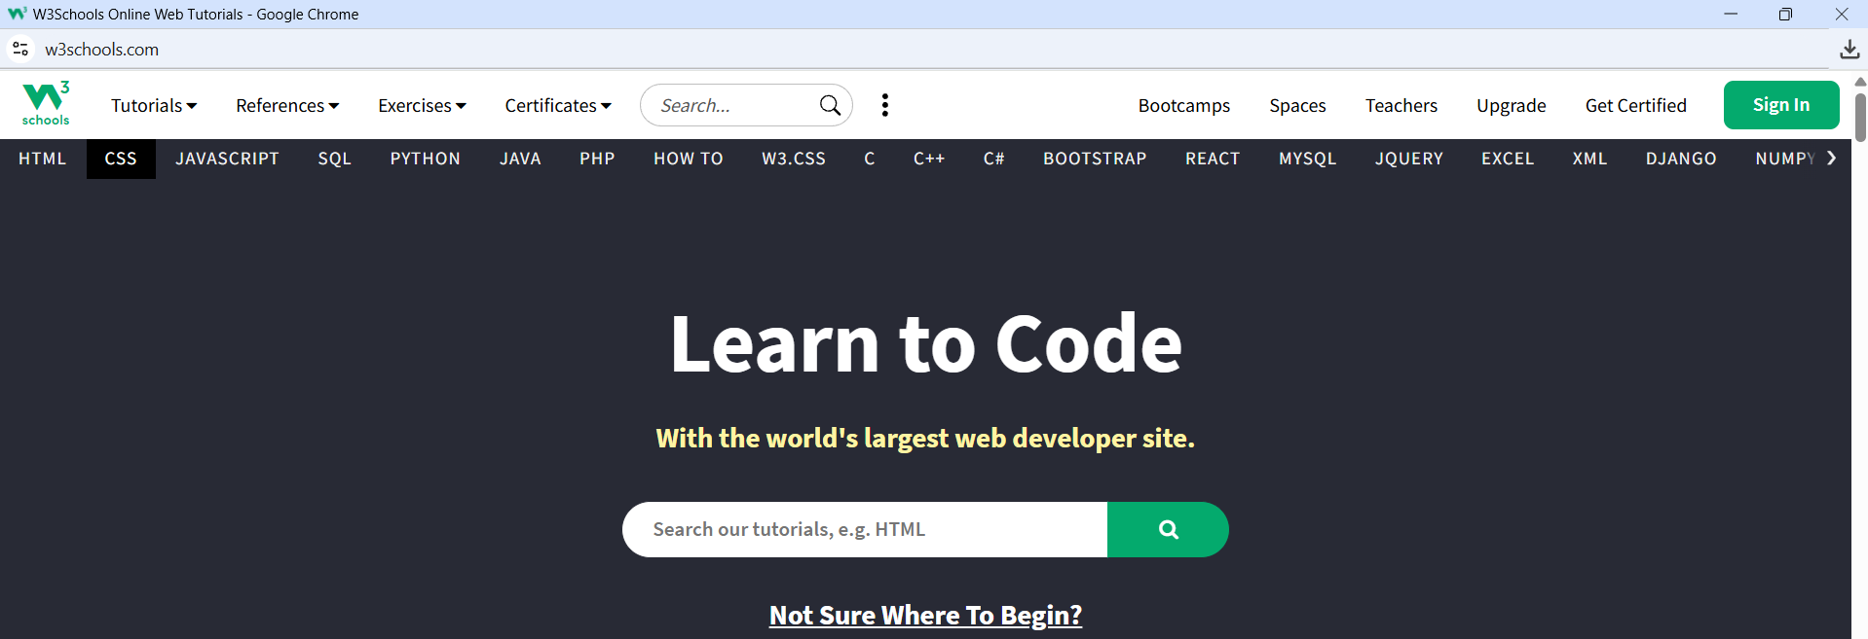

6. Open multiple new windows:
<html>
<head>
<script type="text/javascript"> function open_win()
{
window.open("http://www.microsoft.com/");
window.open("http://kishor.ucoz.com");
}
</script>
</head>
<body>
<form>
<input type=button value="Open Windows" onclick="open_win()">
</form>
</body>
</html>
OUTPUT:
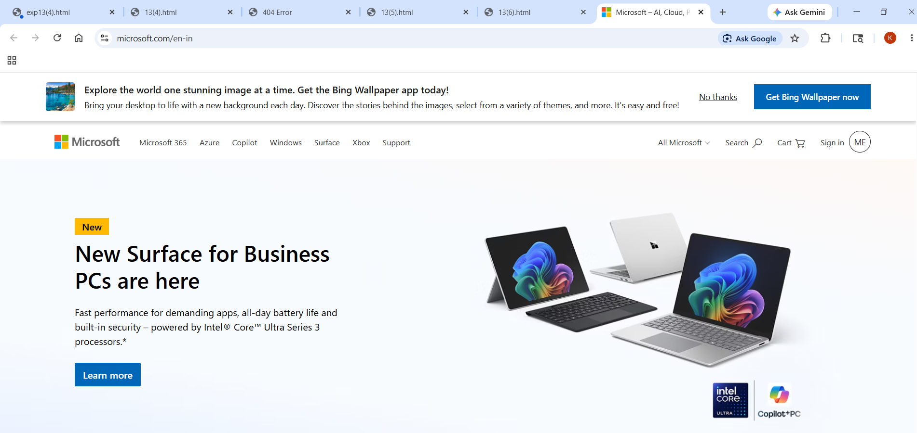

7. Close the new window
<html>
<head>
<script type="text/javascript"> function openWin()
{
myWindow=window.open("","","width=200,height=100");
myWindow.document.write("<p>This is 'myWindow'</p>");
}
function closeWin()
{
myWindow.close();
}
</script> </head>
<body>
<input type="button" value="Open 'myWindow'" onclick="openWin()" /> <input type="button" value="Close 'myWindow'" onclick="closeWin()"/>
</body>
</html>
OUTPUT:
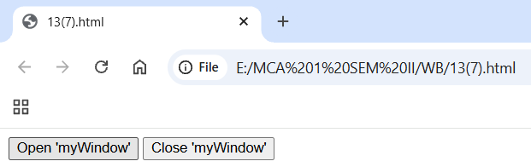
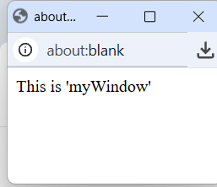
8. Print the current page
<html>
<head>
<script type="text/javascript"> function printpage()
{ window.print(); }
</script>
</head>
<body>
<input type="button" value="Print this page" onclick="printpage()" />
</body>
</html>
OUTPUT:
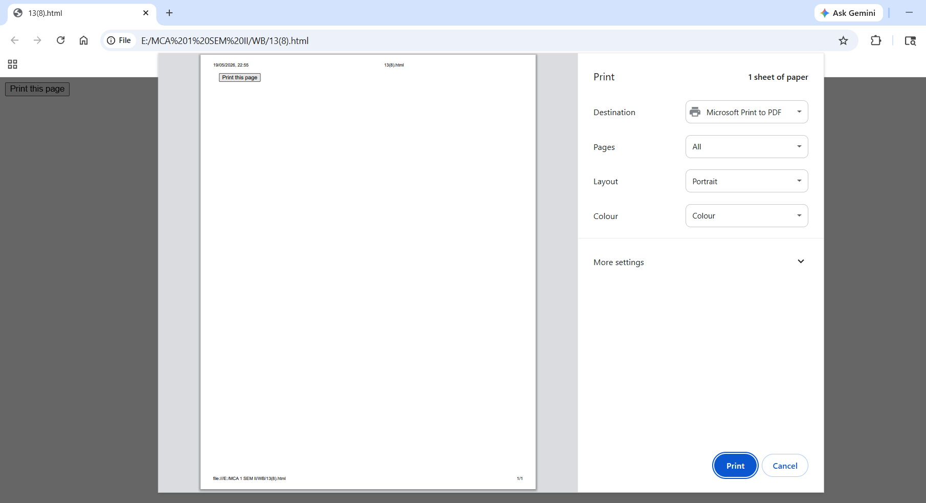
9. A simple timing.
<html>
<head>
<script type="text/javascript"> function timeText()
{
var t1=setTimeout("document.getElementById('txt').value='2 seconds!'",2000);
var t2=setTimeout("document.getElementById('txt').value='4 seconds!'",4000);
var t3=setTimeout("document.getElementById('txt').value='6 seconds!'",6000);
}
</script>
</head>
<body>
<form>
<input type="button" value="Display timed text!" onclick="timeText()"/>
<input type="text" id="txt" />
</form>
<p>Click the button above. The input field will tell you when two, four,
and six seconds have passed…..</p>
</body>
</html>
OUTPUT:
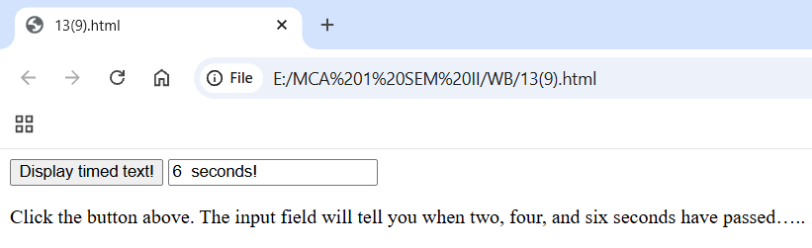

LAB EXERCISE 14

1.My First php Program to display Hello World.
<html>
<body>
<h1>My first PHP page</h1>
<?php
echo "Hello World!";
?>
</body> </html>
OUTPUT:
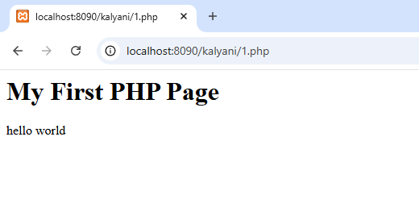

2.To demonstration of Comments in PHP.
<html>
<body>
<?php
//This is a single-line comment
#This is also a single-line comment

/*This is a multiple-lines comment block that spans over multiple lines */
//You can also use comments to leave out parts of a code line
$x=5/*+15*/+5; echo $x; ?>
</body> </html>
OUTPUT:
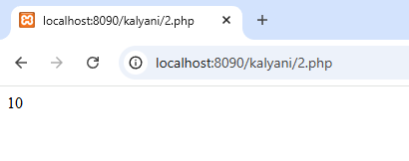

3.String Length.
<html>
<body> <?php
echo strlen("CIMDR MCA!");
?>
</body> </html>
OUTPUT:
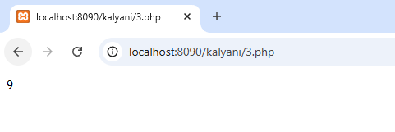
4.Count the Number of Words in a String.
<html>
<body> <?php
echo str_word_count("Hello world!");
?>
</body>
</html>
OUTPUT:
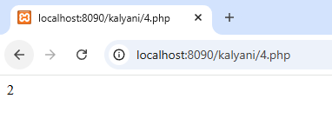

5.To demonstration of variable GLOBAL SCOPE- and can only be accessed outside function . <html>
<body>
<?php
$x=5;//global scope
function myTest()
{
global $x;
//using x inside this function will generate an error
echo "<p> Variable x inside function
is:$x</p>";
} myTest();
echo"<p> Variable x outside function is
:$x</p>";
?>
</body>
</html>
OUTPUT:
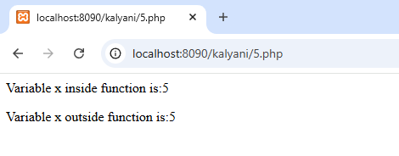

6.A variable declared within a function has a LOCAL SCOPE and can only be accessed within that function .
<html>
<body> <?php
function myTest()
{
$x = 5;
echo "<p>Variable x inside function is: $x</p>";
}

myTest();

// Outside variable
$x = 10;
echo "<p>Variable x outside function is: $x</p>";
?> </body>
</html>
OUTPUT:
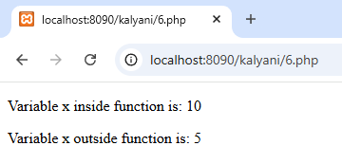
7.Swapping Using Third Variable.
<?php
$a=45;
$b=78;
$third=$a;
$a=$b; $b=$third;
echo "After swapping:<br><br>";echo "a=".$a." b=".$b; ?>
OUTPUT:

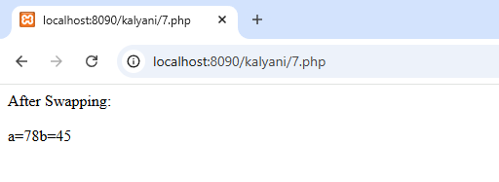

8.Swapping without Using Third Variable(+ and -).
<?php
$a=234;
$b=345;
$a=$a*$b;
$b=$a/$b; $a=$a/$b;
echo "Value of a: $a</br>"; echo "Value of b: $b</br>"; ?>
OUTPUT:
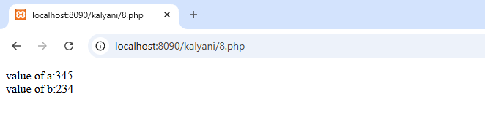
9.PHP script for generating a list of prime numbers below 100.
<?php
$number=2;
while($number < 100)
{
$div_count=0;
for ($i=1;$i<=$number;$i++)
{
if(($number%$i)==0)
{
$div_count++;
}
}
if($div_count<3)
{
echo$number." , ";
}
$number=$number+1;
}
?>
OUTPUT:
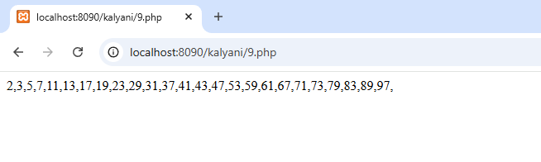
10.Factorial of a Number.
<?php
$num = 4;
$factorial = 1;

for ($x = $num; $x >= 1; $x--) {
$factorial = $factorial * $x;
}

echo "Factorial of $num is $factorial";
?>
OUTPUT:
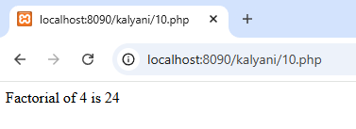

11.Palindrome number program without of using PHP predefined function.
<?php
$number=53235;
$p=$number; $revnum=0;
while($number!=0)
{
$revnum=$revnum*10+$number % 10;
$number=(int)($number/10);
} if($revnum==$p)
echo $p.'is palindrome number'; else
echo 'number is not palindrome'; ?>
OUTPUT:
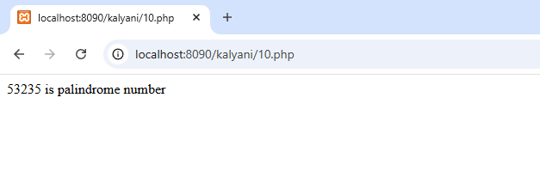

12.Reversing number in PHP.
<?php
$num=23456; $revnum=0; while($num>1)
{
$rem=$num%10;
$revnum=($revnum*10)+$rem;
$num=($num/10);
}
echo"Reverse number of 23456 is :$revnum";
?>
OUTPUT:
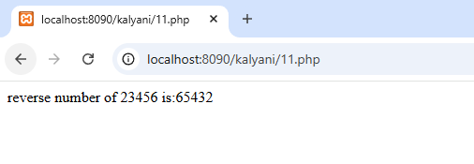

LAB EXERCISE 15

Q. Demonstration of different types of Inheritance.
1.Single Inheritance
<html>
<body>
<script type="text/javascript"> class A { fooA() {
document.write("Class A Method<br>");
}
} class B extends A { fooB() {
document.write("Class B Method<br>");
}
} var obj = new B(); obj.fooA(); obj.fooB(); </script>
</body> </html>
OUTPUT:
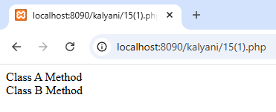
2Multi-level inheritance
<html>
<body> <?php class A { public function fooA() {
echo "Class A Method (Grandparent)<br>";
}
} class B extends A { public function fooB() { echo "Class B Method (Parent)<br>";
}
} class C extends B { public function fooC() { echo "Class C Method (Child)<br>";
}
}
$obj = new C();
$obj->fooA();
$obj->fooB();
$obj->fooC();
?>
</body> </html>
OUTPUT:
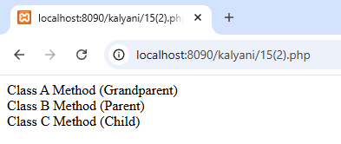
3.Multiple inheritance
<html>
<body> <?php interface A { public function fooA();
} interface B { public function fooB();
}
class C implements A, B { public function fooA() {
echo "Class A Method (Implemented in C)<br>";
}
public function fooB() {
echo "Class B Method (Implemented in C)<br>";
}
public function fooC() { echo "Class C Method<br>";
}
}
$obj = new C();
$obj->fooA();
$obj->fooB();
$obj->fooC();
?>
</body> </html>
OUTPUT:
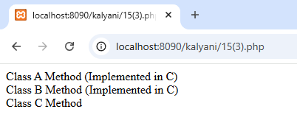
4.Multipath Inheritance
<html>
<body>
<?php
trait A { public function fooA() {
echo "Class A Method<br>";
}
}

trait B {
public function fooB() {
echo "Class B Method<br>";
}
} class C { use A, B; public function fooC() {
echo "Class C Method<br>";
}
}

$obj = new C();
$obj->fooA();
$obj->fooB();
$obj->fooC();
?>
</body> </html>
OUTPUT:
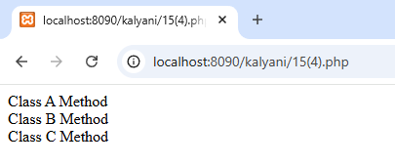

5. Hierarchical Inheritance
<html>
<body> <?php trait ParentTrait { public function parentMethod() {
echo "Method from Parent Trait<br>";
}
} class ChildA { use ParentTrait; public function methodA() {
echo "Method from Child A<br>";
}
} class ChildB { use ParentTrait; public function methodB() {
echo "Method from Child B<br>";
}
}
$objA = new ChildA();
$objA->parentMethod();
$objA->methodA();
echo "<br>"; $objB = new ChildB();
$objB->parentMethod();
$objB->methodB();
?>
</body> </html>
OUTPUT:
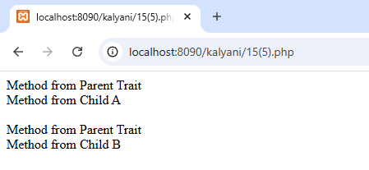

LAB EXERCISE 16

Q. Student Information Form Using POST Method
<!DOCTYPE html>
<html>
<head>
<title>POST Student Form</title>
<style> body { font-family: Arial, sans-serif; background-color: #f0f4f8; padding: 40px;
}
.form-box { background-color: #fff; padding: 20px; width: 300px; margin: auto; border-radius: 8px; box-shadow: 0 2px 5px rgba(0,0,0,0.1);
}
input[type="text"], input[type="submit"] { width: 100%; padding: 10px; margin-top: 10px; border-radius: 4px; border: 1px solid #ccc;
}
input[type="submit"] { background-color: #4CAF50;
color: white; border: none; cursor: pointer;
}
input[type="submit"]:hover { background-color: #45a049;
}
.result {
margin-top: 20px; background-color: #e8f5e9; padding: 15px; border-left: 5px solid #4CAF50;
}
</style>
</head>
<body>
<div class="form-box">
<h2>POST Method - Student Info</h2>
<form method="post" action="">
Name: <input type="text" name="name"><br>
Roll No: <input type="text" name="roll"><br>
Course: <input type="text" name="course"><br>
<input type="submit" value="Submit">
</form>
<?php
if ($_SERVER["REQUEST_METHOD"] == "POST" && !empty($_POST['name'])) {
$name = htmlspecialchars($_POST['name']);
$roll = htmlspecialchars($_POST['roll']); $course = htmlspecialchars($_POST['course']); echo "<div class='result'>";
echo "<strong>Submitted via POST:</strong><br>"; echo "Name: $name <br>"; echo "Roll No: $roll <br>"; echo "Course: $course <br>"; echo "</div>";
}
?>
</div>
</body>
</html>
OUTPUT:
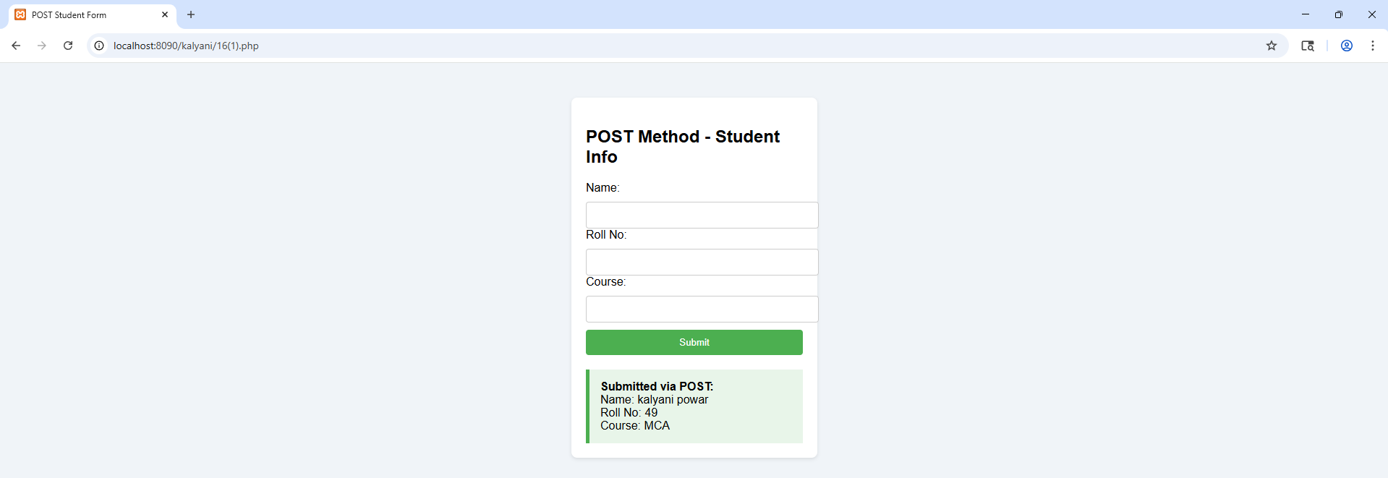
Q. Student Information Form Using GET Method
<!DOCTYPE html>
<html>
<head>
<title>GET Student Form</title>
<style> body { font-family: Arial, sans-serif; background-color: #f0f4f8; padding: 40px;
}
.form-box { background-color: #fff; padding: 20px; width: 300px; margin: auto; border-radius: 8px; box-shadow: 0 2px 5px rgba(0,0,0,0.1);
}
input[type="text"], input[type="submit"] { width: 100%; padding: 10px; margin-top: 10px; border-radius: 4px; border: 1px solid #ccc;
}
input[type="submit"] { background-color: #2196F3;
color: white; border: none; cursor: pointer;
}
input[type="submit"]:hover { background-color: #1976D2;
}
.result {
margin-top: 20px; background-color: #e3f2fd; padding: 15px; border-left: 5px solid #2196F3;
}
</style>
</head>
<body>
<div class="form-box">
<h2>GET Method - Student Info</h2>
<form method="get" action="">
Name: <input type="text" name="name"><br>
Roll No: <input type="text" name="roll"><br>
Course: <input type="text" name="course"><br>
<input type="submit" value="Submit">
</form>
<?php
if ($_SERVER["REQUEST_METHOD"] == "GET" && isset($_GET['name']) &&
!empty($_GET['name'])) {
$name = htmlspecialchars($_GET['name']);
$roll = htmlspecialchars($_GET['roll']); $course = htmlspecialchars($_GET['course']); echo "<div class='result'>";
echo "<strong>Submitted via GET:</strong><br>"; echo "Name: $name <br>"; echo "Roll No: $roll <br>"; echo "Course: $course <br>"; echo "</div>";
}
?>
</div>
</body>
</html>
OUTPUT:
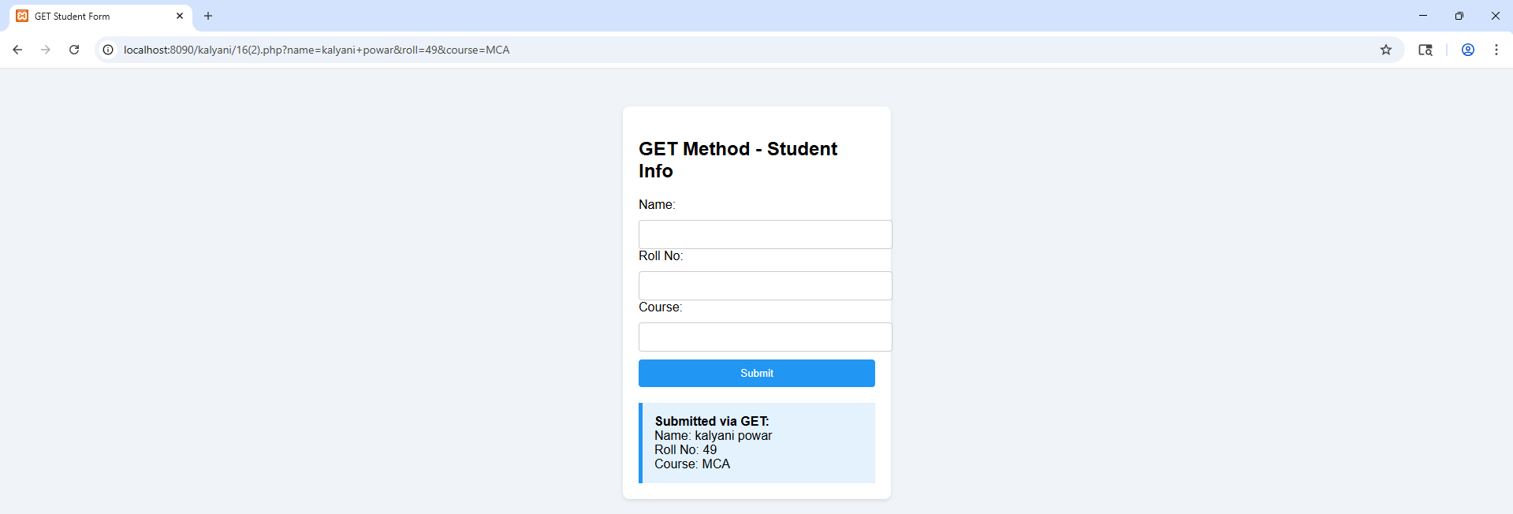

LAB EXERCISE 17

1. To create a database in MySQL
<?php
$servername = "localhost";
$username = "root";
$password = "";
$conn = mysqli_connect($servername, $username, $password); if (!$conn)
die("Connection failed: " . mysqli_connect_error());
$sql = "CREATE DATABASE myDB";
if (mysqli_query($conn, $sql)) echo "Database created successfully"; else
echo "Error creating database: " . mysqli_error($conn); mysqli_close($conn);
?>
OUTPUT:
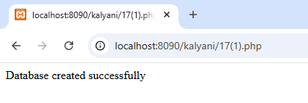
2.To select a database in MySQL
<?php
$servername = "localhost";
$username = "root";
$password = "";
// Create connection
$conn = mysqli_connect($servername, $username, $password);
// Check connection if (!$conn) {
die("Connection failed: " . mysqli_connect_error()); }
// Select database
$db = "myDB";
if (mysqli_select_db($conn, $db)) { echo "Database selected successfully";
} else {
echo "Error selecting database: " . mysqli_error($conn);
}
// Close connection
mysqli_close($conn);
?>
OUTPUT:
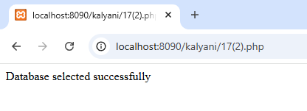

LAB EXERCISE 18

1. Demonstration on session
<?php session_start(); // store session data
$_SESSION['views']=1;
?>
<html>
<body>
<?php
//retrieve session data
echo "Pageviews=". $_SESSION['views'];
?>
</body>
</html>
OUTPUT:

2. Demonstration on UPLOADING FILE
<?php
if(isset($_FILES['image']))
{
$errors= array();
$file_name = $_FILES['image']['name'];
$file_size = $_FILES['image']['size'];
$file_tmp = $_FILES['image']['tmp_name'];
$file_type = $_FILES['image']['type'];
$file_ext=strtolower(end(explode('.',$_FILES['image']['name'])));
$expensions= array("jpeg","jpg","png"); if(in_array($file_ext,$expensions)=== false)
{ file."; }
}
}
$errors[]="extension not allowed, please choose a JPEG or PNG if($file_size > 2097152) {
$errors[]='File size must be excately 2 MB';
if(empty($errors)==true) { move_uploaded_file($file_tmp,"images/".$file_name); echo
"Success"; else{
print_r($errors);
}
}
?>
<html>
<body>
<form action = "" method = "POST" enctype = "multipart/form-data">
<input type = "file" name = "image" />
<input type = "submit"/>
<ul>
<li>Sent file: <?php echo $_FILES['image']['name']; ?>
<li>File size: <?php echo $_FILES['image']['size']; ?>
<li>File type: <?php echo $_FILES['image']['type'] ?>
</ul>
</form>
</body>
</html>
OUTPUT:
